Manual

Online measurements of ammonia using dynamic flux chambers

Materials and start up protocol

Overview
Details of the setup can be found in:
Pedersen, et al. 2024. https://doi.org/10.5194/amt-17-4493-2024
In brief, the setup consists of 16 dynamic flux chambers connected to a cavity ring-down spectrometer. Each chamber has a tube for measuring emissions in the chamber, and three of the chambers have a background tubing to measure the background concentration of NH3. The airflow through the tunnels is created with a fan driven by a moter.
All tubing is heated and insulated. The tubing goes to two valves connected to be operated as one. The valves are controlled by the cavity ring-down spectrometer (picarro). From each tubing air is drawn for 8 minutes (air will be drawn from tubing in the same time-intervals during one experiment, the interval length can be changed). A heated tube leads air from the valve to the picarro where it is analyzed for NH3 concentration.
The setup can be used to for testing the relative difference in ammonia emissions from different treatments (e.g. application techniques, slurries soil-type). For handheld slurry application it is usually sufficient with three replicates, whereas four or more replicates are recommended for machine applied slurry.
Other analyzers can be connected in series with the picarro, such as PTR-MS.

This document contains the list of materials needed to run an experiment with the wind tunnels.

Materials
Equipment:
- Instruments and tunnels:
  - Dynamic flux chambers:
    - Chambers, 16
    - Heated and insulated tubes (15 m), 16
    - Extra insulation tube
    - Plastic ‘hats’ for tube connection to the chambers, 16
  - Cavity ring-down spectrometer
    - Instrument
    - Pump (after Picarro)
    - Computer screen, mouse and keyboard
    - Drying unit for when shutting down the instrument in the field
  - Valve-box:
    - 10-port vici valve, ¼”, 2
    - Power cords, 3 with 8 power connections in each
  - Manometer
  - Cables to ensure power supply into the setup
  - Optional: internet connection

- Slurry:
  - If slurry is machine applied then ensure that everything is running propperly
  - If slurry is manually applied:
    - Watering can with hose
    - Measuring cylinder or weight for slurry
  - Sampling containers. Usually 2*250 mL for analysis and 2*100 mL for long-term storage (in case extra analysis is needed) pr slurry/slurry treatment type

- Others
  - Hulla-hoops for marking plot area for chambers
  - Optional: Frames/rings for outside the chambers if they cannot be pushed into the soil and sand for the frame/rings
  - Clip chart with protocol and data collection sheets
  - DFC/wind tunnel toolbox
  - pH toolbox
  - Soil sampling toolbox
  - Extra big box with duct tape, extra ¼” Teflon tubing, gloves, tissues, Blanket (to heat picarro if it is very cold), flowmeter
  - Optional: NH3 (g), 10 ppm (if setup needs to be tested)

Procedure
Before trial start
- Picarro:
  - Check the filter inside the picarro.
  - Calibrate if necessary.
  - If the Picarro has been turned off for some time (> 1 week), it should be turned on a couple of days before the experiment to ensure that it stabilizes.
  - Pause windows updates for the duration of the trials.
  - If several experiments are made in a row, restart the Picarro between each experiment.
- Check air filters on chambers, change them if needed.
Assembling in the field before slurry application
- Manual application: place hula hoops to mark the plot and place the chambers next to them.
- Machine application: plan the placement after application and place the tunnels outside the machine plots and assemble them. Remember to consider which order you’ll put them in place on the applied slurry to avoid unnecessary tangling of the tubing.
- Connect tubing to tunnels and isolate with insulation pipe and place the protection cap on top. Everything has a number. Tube #1 should be placed on DFC1 etc.
- Power and instrument
  - Connect to the valve box. One power cord in its own ‘power phase’. Ensure that only half of the heating cables are connected to each power cord when starting up. Thereafter, the rest can be added one-by-one.
  - Turn on the pump for the picarro, then turn on Picarro (on/off switch at the back of the picarro, then the round button at the front) and ensure that the valves are connected properly, see ‘valve document’ for details.
  - Connect the power to the chambers and start the motors.
  - Optional: Check recovery of NH3 gas from one of the tubes and compare with measurement directly on the Picarro.
Start of experiment
- Take soil samples if needed.
- Take slurry samples if needed.
- Instrumentation check:
  - Check that the picarro is running, and that the valves are all switching as intended
  - Optional: connect the internet, start team-viewer or anydesk and check that it is working.
- NH3 measurement start
  - Machine application:
    - Apply the slurry
    - Place the chamber(s) on top of the slurry
    - Restart the valve sequencer so that it starts with valve 1 for DFC1 by clicking the ‘Apply’ button in the valve sequencer GUI.
  - Manual application
    - Wight/measure the wanted amount of slurry
    - Apply the slurry in two bands within the hula-hoop
    - Place the chamber on top of the slurry
    - Restart the valve sequencer so that it starts with valve 1 for DFC1 by clicking the ‘Apply’ button in the valve sequencer GUI.
  - When the chambers are placed, they must be pushed into the ground to create an airtight seal. If it is not possible due to e.g. hard soil a frame/ring can be place around it and fill this with sand.
  - Measure ΔPa
  - Record data in the data sheet.
End of experiment
- Save data to a USB if you want. It is found here: Picarro(C:) / UserData / DataLogUser / ‘year’ / ‘month’ /. For each day, a new map with the picarro data is created automatically.
- Attach the ‘drying unit’ to the picarro, so that it runs on dry air before shutting down. Run it with the drying unit attached until the water content recorded by the picarro is very low, usually just a very short time is needed.
- Shut down the Picarro by pressing ‘shutdown’.
  - OBS: Do not turn off the pump before the Picarro has been shut down. To protect the Picarro let the pump run 2 minutes after the Picarro has shut down.
- Measure ΔPa
- Record data in the data sheet.
- Disassemble everything.
- Place filter heads in all the tubing ends.

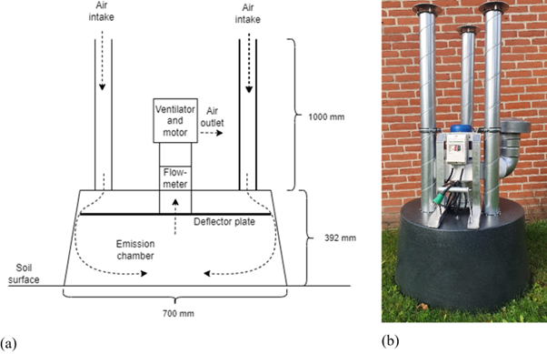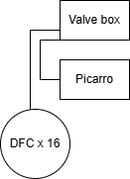

Application by 3-m boom
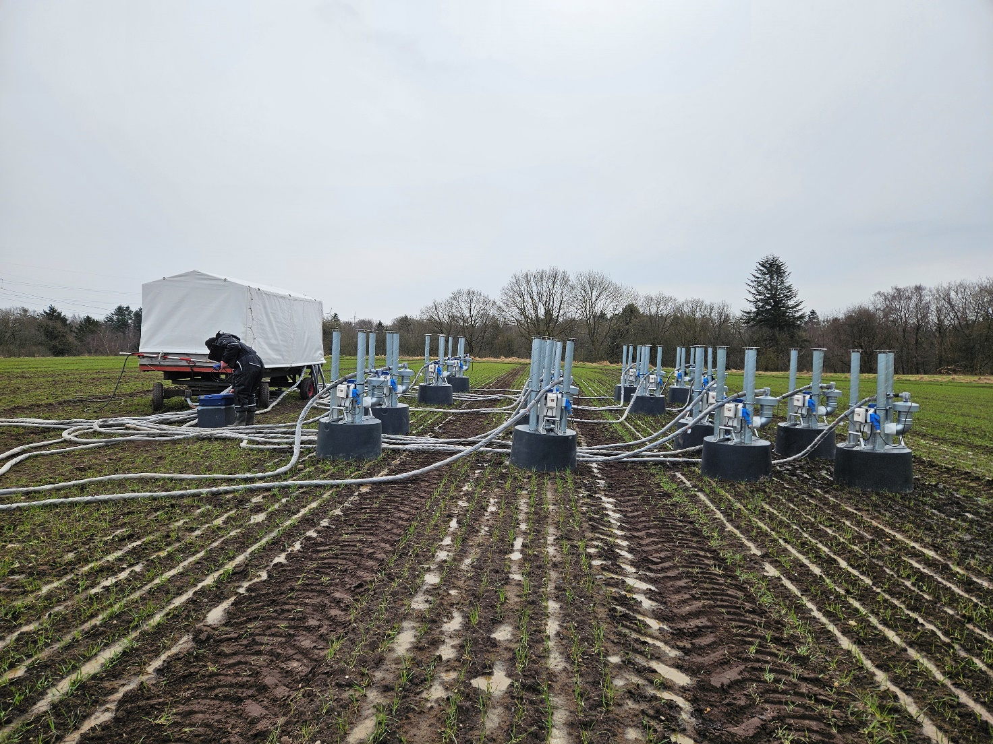
Applicationmethod 1
Applicationmethod 2
Applicationmethod 3
Applicationmethod 4

Application by 3-m boom with yield plots
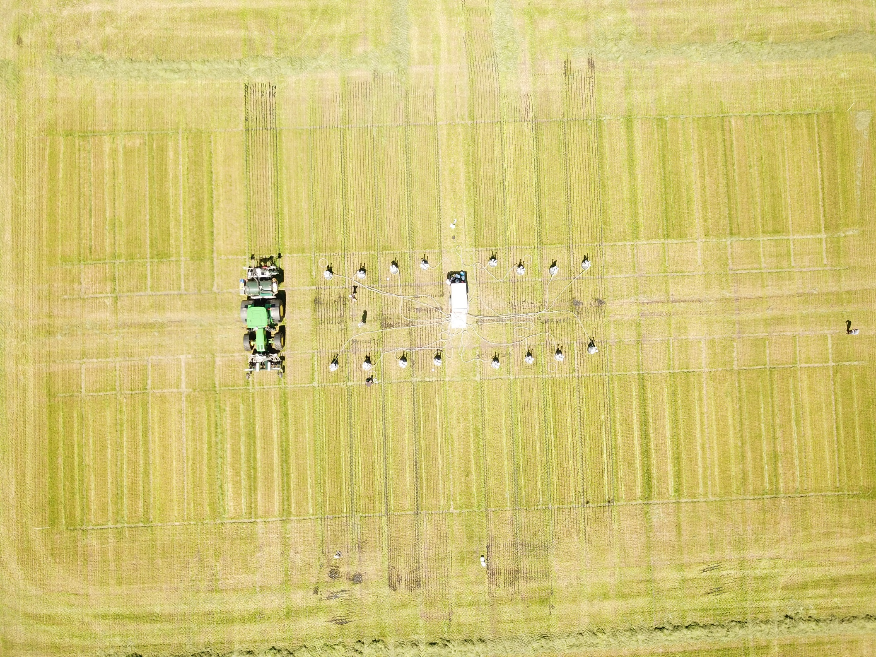
Application
method 4
Application
method 3
Application
method 2
Application
method 1

